

HBUT Preparatory Guide
for International Students

International Student Office
School of International Education
Aug. 2015

Table of Contents
- Welcome
- Admission
·Basic Ideas of the Campus
·When shall I arrive
·Getting to HBUT
·Foreign Currency Exchange
·Admission Procedure
·Finance
·Accommodation
·Medical Service
·Visa and Residence Permit
·Emergency Contact Person
- Life at HBUT
·Campus Map & Traffic
·Student Card
·Food and Drinks
·Water, Electricity, Air Conditioning and Hot Water Supply

1. Welcome

Greetings from School of International Education of Hubei University of Technology and welcome you here!
This guide is mainly for the foreign students who come to Wuhan for the first time, provides as much information for your life and helps you acclimate yourself here.
Although possibly you have used products made in China, or many of your friends are from China, even you yourself are a foreign citizen of Chinese origin; China is probably still a land of strangeness and mystery to you. We understand that you may consider it a challenging adventure to your life to make this decision to study in China.
It is strongly recommended to arrange some time to read this guide carefully. Many of your solutions must be covered in it.
This guide is still being updated and you are encouraged to submit your questions and suggestions. Please send your ideas to the maintenance personnel of this guide via email: SIE@mail.hbut.edu.cn.

- Admission
·Basic Ideas of the Campus
Hubei University of Technology, founded in 1952, is a provincial multidisciplinary university. There are about 20,000 full time undergraduates and 1500 graduates on campus. The University offers 60 Bachelor programs and 75 Master programs.
Currently, HBUT has more than 1700 faculty and administrative staff, among whom over 600 have senior profession title. Under the background of international education and communication, HBUT has already established cooperation with 30 universities abroad. It attaches great importance to international exchange and scientific research cooperation, and an average of over 300 faculty and students go aboard for academic exchange annually.
Hubei University of Technology is located in the Southern part, in the Hongshan District of Wuhan city. It is about 60 kilometers from the Wuhan Tianhe International Airport.
Hubei University of Technology has a campus of about 107 hectares. It is 1.5 kilometers from north to south and 1.2 kilometers from east to west.
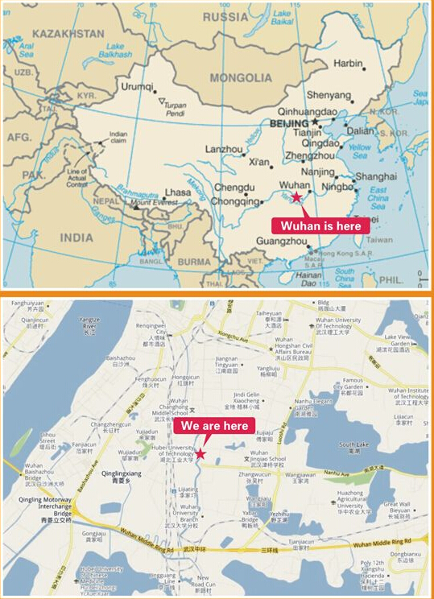
·When shall I arrive
It is suggested that every students arrive on the days of registration indicated on the Admission Notice. Try not to be ahead or late of schedule.
Some problems may be caused by coming too early: the apartment has not arranged enough rooms, the School of International Education is still on holiday and not able to accept registration.
The work time for School of International Education is 8:00-11:30, 14:00-17:30, public holidays and school holidays excluded.
You are expected to arrive at the university in the work time of School of International Education, so that you can register on your arrival. However, if you fail to arrive on time because of the flight timetable or other reasons, there is no need to worry much. In that case you can contact the apartment manager and check-in, and register on the next work day.
·Getting to HBUT

Route Transport Tool Required Time Expense (RMB)
From Wuhan Tianhe Taxi 1.5 hours 150 yuan
International Airport to HBUT
From Wuchang Railway Taxi 0.5 hour 25 yuan
Station to HBUT
From Hankou Railway Taxi 1 hour 70 yuan
Station to HBUT
From Wuhan Railway Taxi 1 hour 70 yuan
Station to HBUT

If you cannot speak Chinese, you can print out the address description below beforehand and show ti to the taxi driver, which is recommended. You can also ask the driver to call 59750662, the reception of School of International Education for more information.
请带我去湖北工业大学二号教学楼。
具体地址是武昌南湖南李路28号，进学校大门后直走约500米，然后左转约500米，科技楼对面即是二号教学楼。如果仍然不清楚，请致电59750662咨询。
Please take me to Teaching Building No.2, Hubei University of Technology, No. 28 Nanli Road, South Lake, Wuchang. Enter the campus through the Main Entrance (The East Gate), walk straight for about about 500 meters, and then turn left and walk for about 500 meters again. Teaching Building No.2 is on the right of the road, opposite to the Science & Technology Building. Please call 59750662 if still not clear.

Taxi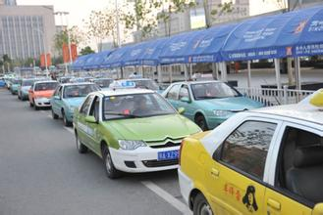
When you take a taxi back to the campus, remember to take the taxi with an authorized sign of “Taxi”, pay the fee shown on the taximeter inside the taxi and keep the printed receipt carefully for possible inquiry for forgotten belongings and any other dissensions in the future.
Every year there are many students who lose their belongings on the taxi, so you should cautious of your belongings when getting off, especially the important and valuable things such as passport, wallet, mobile phone, camera, etc.

·Foreign Currency Exchange
We suggest you change some money into RMB cash on your arrival at Wuhan Tianhe International Airport. The currency exchange service is accessible at Gate T2 on the first floor. Several hundreds of RMB is reasonable.
Many bank outlets in Wuhan provided foreign currency exchange service. You can change your money into RMB conveniently.
It is strongly suggested that students should not go to the place unauthorized to change money. You will risk the possibility of forged notes at these places not eligible to exchange.

·Admission Procedure
Admission Procedure for New Students
Register and Pay the Fees
1. Students take the Admission Notice and JW202 Form to the International Student Office to register and make the confirmation: Language program class or Degree program class, then collect the demand note and go to the Finance Department to pay the fees.

Accommodation
2. After the payment, students submit the payment receipt to International Student Office for scan and archive. International Student Office arrange the accommodation and issue the water card and electricity card.

Medical Examination
Students take the passport to Hubei International Travel Health care Center to take the medical examination. Students can go there by cars arranged by International Student Office or by themselves. (Address: No. 457 South Luoshi Road, Hongshan District, opposite to the Bureau 3 of CSCEC Hospital)
Residence Registration
Students go to International Student Office to fill in the Residence Registration Form within 2 days after registration, then take the original passport and residence registration form to South Lake Police Station to apply for residence registration.

Apply for a Residence Permit
One week later, students go to International Student Office to collect the following documents: Study Certificate, Foreigner Visa Documents Application Form, Residence Registration Form, Health Certificate, Admission Notice, JW202 Form, Record of the Interview for Residence Permit, and take those documents with the passport to Exit and Entry Administration Department of Wuhan Public Security Bureau to apply for a residence permit. (within 2 weeks after entry or 2 weeks before visa expiration)

·Finance
- Charging Standards for International Student at HBUT (RMB)
Items | Amount (RMB)
Chinese Delivery  Tuition |  | Liberal Arts |  | Engineering |  | Art and Design
Chinese Delivery  Tuition | Bachelor | 18000yuan/year |  | 20000yuan/year |  | 23000yuan/year
Chinese Delivery  Tuition | Master | 21000yuan/year |  | 23000yuan/year |  | 25000yuan/year
Chinese Delivery  Tuition | Chinese Language Training | 12000yuan/year
English Delivery  Tuition | Bachelor | 20000yuan/year |  | 22000yuan/year |  | 25000yuan/year
English Delivery  Tuition | Master | 23000yuan/year |  | 25000yuan/year |  | 27000yuan/year
Accommodation | Single Room |  | Double Room |  | Triple Room
Accommodation | 10000yuan/year |  | 6000yuan/year |  | 4000yuan/year
Registration | 400 yuan
Medical Insurance | 600 yuan/year
Materials | 600-800 yuan/year

- Payment Procedure
Students go to International Student Office to collect Demand Note of SIE, HBUT and go to the Finance Department to pay the fees. After the payment, students submit the payment receipt to International Student Office for scan and archive. International Student Office arrange the accommodation and issue the water card and electricity card to students.

·Accommodation
International Student Apartment provides on-campus accommodation for all international students of HBUT. Except for the furniture, the apartment is equipped with free internet, air conditioner, water heater, refrigerator and other facilities. Besides, students have access to public kitchen and laundry.
According to the law and the relevant policy, the International Student Apartment are only able to host foreign students who register in HBUT. Neither relatives nor friends of students nor other persons are allowed to live in the apartments. Students living in the apartment should comply with the administrative regulations. For instance, lighting fire, including using candles in strictly prohibited in the rooms; students are not allowed to host other people overnight in the rooms, etc.
Students are not allowed to change rooms without permission. If there is need, students can raise the demand a week in advance, and the apartment manager will arrange for the change according to the actual housing situation.
·Medical Service
- Newly-arrived students who enter China with X visa should go to Hubei International Travel Health Center for medical verification upon arrival. Those who fail to satisfy the requirements may be asked to complete the medical examination again at the Center. Those who are not suitable for study because of illness are requested to return home immediately.
- Students are given Medical Treatment Card about two weeks later at the time of registration upon arrival at the university. With the card, they are entitled to public medical services at the campus hospital and enjoy the same medical treatment as the Chinese students.
- Students who need to consult doctors in an off-campus hospitals may pay for the medical expenses themselves first and then, with the receipt, medical record, hospitalization record and so on, can claim for compensation for medical cost at the insurance company. For hospitalization off campus, the insurance company will bear a certain amount of the fees for treatment and bed in accordance with the related regulations, while the students themselves pay the minor amount and all the board expenses. Please refer to the insurance contract for the insurance coverage. All the hospitalization compensation must be in accordance with the proportion and requirements of social medical insurance claims in China, the exceeding amount should be on students’ own expense.
In accordance with the regulations of the Ministry of Education of China, the self-funded students who will study in the Chinese universities for half a year or more will have to purchase the Overall Insurance and Benefit Plan for International Students in the insurance company in China’s mainland, thus their possible accidental injury medical treatment expense and hospitalization medical expense can be covered by the insurance company. Students without medical insurance are not allowed to register in HBUT.
Students who purchase Insurance (including accidental injury medical treatment insurance, hospitalization medical insurance and emergency medical service in China’s mainland) should pay 600 yuan/year. The Insurance Plan is compulsory to undergraduates and graduates. Students who refuse to purchase insurance are prohibited to register in HBUT.
4. Anyone who violated the law and regulations resulting in accidental injuries should be responsible for all the subsequent expenses incurred.

·Visa and Residence Permit
- Entry Visa
- Students go to the diplomatic missions outside of China with valid ordinary passport, Admission Notice, JW202 Form to apply for an X1 or X2 visa.
- When you go to collect your passport and visa, please make sure that the diplomatic missions return the Admission Notice and JW202 Form to you. After you enter China, you need to submit those documents to Exit and Entry Administration Department of Wuhan Public Security Bureau to apply for a residence permit.
- The university only apply for residence permit for students who have already registered. It is suggested that students with an X, F or L visa enter China within 1 week in advance of the registration date.
- Residence Permit
- Conditions for residence permit:
- Newly arrived students holding the L visa or F visa valid for 30 days after entrance are requested to apply for a residence permit in the Exit and Entry Administration Department of Wuhan Public Security Bureau within 30 days after entrance if their visa expires before their study ends.
- Students who will study in China for half a year or more should apply for a residence permit.
- Students who will study in China for less than half a year and whose study period ends before the visa expires do not need to apply for a residence permit.
- Procedures of applying for a residence permit
- Students should take the Admission Notice (both the original and the copy), JW202 Form, Registration Form of Temporary Residence for Visitors from Overseas, Passport (both the original and the copy), 2 Photos of 2 inches, and Health Certificate issued by Hubei Provincial Entry-Exit Inspection and Quarantine Bureau (students who will study for less than half a year do not need to provide this document) to International Student Office to apply for the Certificate of International Student.
- Students bring the above-mentioned documents to the Exit and Entry Administration Department of Wuhan Public Security Bureau to apply for a residence permit.

Students should apply for a residence permit before the visa expires because staying with expired visa is treated as illegal, and it will leads to punishment by public security bureau of China.

·Emergency Contact Person

Students should leave their family members’ contact information when they are registered in the university.
In accordance with related regulations and rules, when students have the emergency situation of life risk, the university should provide necessary assistance as long as informed. At the same time, the university should inform the Chinese Embassy in the country of the student and ask for help to contact the family. Some medical means (such as surgery) can be operated only if it is signed by a family member or authorized person. The accurate family members’ contact information is of vital importance in case of any emergency situation.

- Life at HBUT
·Campus Map & Traffic
Campus Map
Cm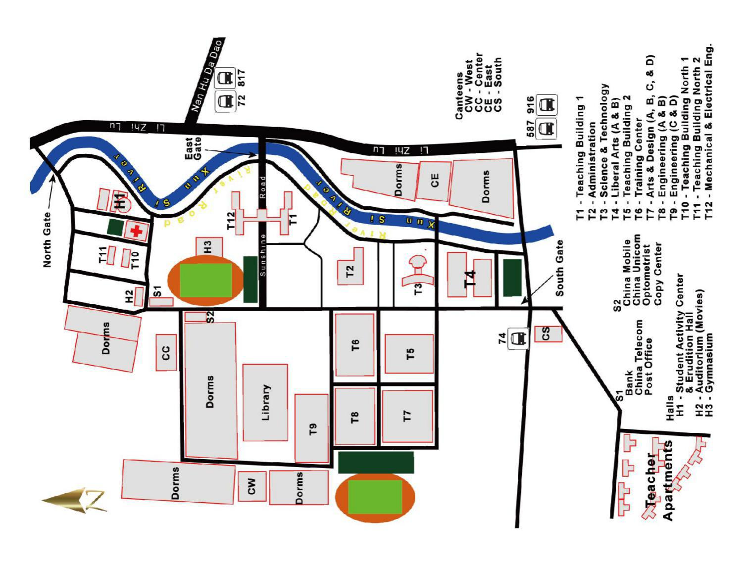
Traffic
Bus Station
- The South Gate (Hugong Nanmen Station): Bus No.74
- The East Gate (Nanli Road HBUT Bus Station): Bus No.74, No.587, No.916
- The Nanhu Avenue (Nanhu Avenue HBUT Station): Bus No.72, No.570, No.817
- The North Gate (Nanli Road Huagong Branch Station): Bus No.72, No.74, No.570, No. 87, No.916

Shopping Center
(1) Wushang Bulksale Chain Company (Hubei Provincial Academy of Agricultural Science Branch)
Address: in the neighborhood of Hubei Provincial Academy of Agricultural Science on Nanhu Avenue
Take bus No. 817 to Shucheng Road Nanhu Avenue Station
(2) Wal-Mart Supercenter Wuhan South Lake Branch
Address: 2nd floor of South Lake Town Plaza in Beigang Village, Nanhu Street
Take bus No.94 or No.916 to Heng’an Road Fu’an Street Station, then change to Bus No.804 to Jian’an Street Dingziqiao South Road
(3) Zhongnan Business District
Address: Zhongnan Road
Take bus No. 587 to Zhongnan Road Zhongnan No.2 Road Station
(4) Simenkou Business District
Take bus No 916 to Linjiang Avenue Hanyangmen Station, and walk along Minzhu Road
(5) Optical Valley Business District
Take bus No. 72 to Luxiang Station

·Student Card
1. Students who will study for half a year or more can apply for HBUT Student Card.
2. Student Card can be used in Library and Cafeteria.
3. Student Card is handled by International Student Office.
4. Student Card Application Procedure:
(1) Students take the Student ID Card to International Student Office to register the application;
(2) International Student Office issue the Letter of Consent;
(3) Students take the Letter of Consent, Student ID Card, 1 Photo of 1 inch to HBUT Campus Card Center to apply for the Student Card;
(4) Student should comply with the regulations of Library and Student Apartment when using the Student Card;
(5) Students return the Student Card to International Student Office 2 weeks before graduation.

·Food and Drinks
There are 6 cafeterias in the campus, providing delicious meals. All the cafeterias accept Student Card for payment, and some accept cash. The Muslim cafeteria is located besides the Lianhe 100 Supermarket situated in the middle campus. The west campus provides shopping, entertainment, body building service apart from food and drinks.
The open time of the students’ cafeteria is 6:30-9:00 for breakfast, 11:00-13:00 for lunch and 17:00-19:00 for supper. Some also serve food at night before 22:00.
Arrange your meal on arrival
If you arrive too late at night, or you do not have enough time to apply for the Dining Card, you cannot have meals in the cafeterias. One solution is to buy some food in the supermarket, which serves late at night until 23:00. You can find bread, cake, hamburger, instant noodles and other quick serve food and drinks. Microwave oven is also served for heating there.

Drinking Water
We need to remind you specially that do not drink the water from the tap directly. At least boil it before you drink. Because of the difference between the sanitary standards of China and other countries, drinking water directly from the tap may cause illness to foreigners. Moreover, since very few Chinese people is seriously allergic to food, if you are allergic to something, do pay attention to the ingredients of the things you are going to eat.

·Water, Electricity, Air Conditioning and Hot Water Supply
Electricity Supply
Students take the Electricity Card given by International Student Office to the Campus Card Center (located in the basement of Building A of Liberal Arts) to recharge, then give the card to the person in charge of apartment management to finish the recharging process in the power distribution house.

Hot Water Supply
Students take the Student Card to the Campus Card Center to recharge.
Usage: Students put the card on the Hot Water Supply System under the shower head, then hot water will be supplied. Hot water will be charged according to water flow, 0.2 yuan for 1 minute water flow.

Heating and Air Conditioning Supply
In order to use the air conditioner, students should take the Student Card to the Campus Card Center (located in the basement of Building A of Liberal Arts) to recharge, then return to Automatic Payment Machine equipped on the 1st floor of the International Student Apartment No.9 to take the following steps:

located in the basement of Building A of Liberal Arts
Press Button F

Press Button 2 to purchase electricity
Press Button 3 to information query

Choose to purchase by amount or quantity
Press Button 2 to Ammeter information query

Enter Room No. 101 and press button “OK”
Enter Room No. and press button “OK”
Enter purchasing amount or quantity and press button “OK”
Dump energy:
Please confirm everything is correct and put the Student Card on the machine

Success in purchasing electricity
Note: 1. If there is no notice of “Payment Success”, please do not move the Student Card.
2. The room No. for Air Conditioner Ammeter should be added “1” before the room No.
e.g. Room No. 101, the corresponding room No for Air Conditioner Ammeter should be 1101.

Hubei University of Technology International Student Service Center
-- School of International Education
School of International Education, Hubei University of Technology is the organization in charge of international student management and service. SIE is responsible for learning consulting, student records management, student visa and residence permit application, teaching arrangement, and international student activities, and other daily management work.

Work Time: 8:00-11:30 & 14:00-17:30 on working days
Address: School of International Education, the 3rd floor of Teaching Building No.2, Hubei University of Technology, No.28 Nanli Road, Hongshan District, Wuhan

Telephone: +86 27 59750662
Email: SIE@mail.hbut.edu.cn

